

Listening – Skill Building

Phonetics

# Level 1:

Learning phonetics helps us improve our listening skills as we are taught to recognize words associated with the pronunciation. Phonetics is a system of symbols used to represent all the sounds in English.

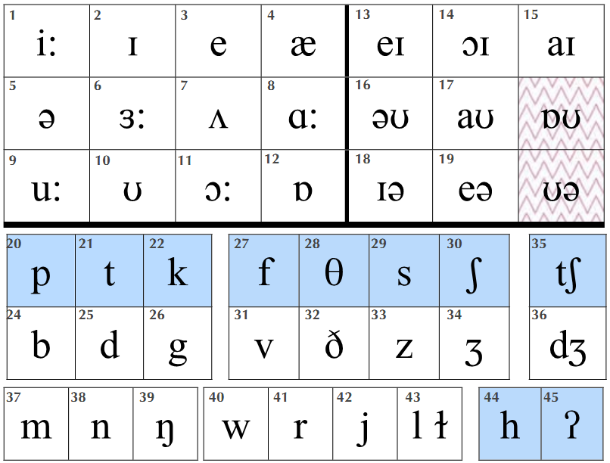

| **Type of sound (A1)** |  | **sound** | | **word-initial** | **word-final** |  |
| --- | --- | --- | --- | --- | --- | --- |
|  |  |  |  |  |  |  |
| **PLOSIVE**  Air in the mouth followed by an explosion of air. |  | /p/ | | **p**ark | Sto**p** |  |
|  | /b/ | | **b**est | lo**b** |  |
|  |  |  |  |  |  |
|  | /t/ | | **t**ime | Migh**t** |  |
|  | /d/ | | **d**one | Pai**d** |  |
|  | /k/ | | **c**art | la**k**e |  |
|  | /g/ | | **g**uide | Fla**g** |  |
|  |  |  |  |  |  |
| **FRICATIVE**  Denoting a type of consonant made by the friction of breath in a narrow opening, producing a turbulent air flow. |  | /f/ | | **f**ine | kni**f**e |  |
|  | /v/ | | **v**an | lea**v**e |  |
|  | /θ/ | | **th**ink | pa**th** |  |
|  |  |
|  | /ð/ | | **th**ose | ba**th**e |  |
|  | /s/ | | **s**ort | pa**ss** |  |
|  | /z/ | | **z**one | chee**s**e |  |
|  | /ʃ/ | | **sh**ip | mar**sh** |  |
|  | /ʒ/ | | - | mea**s**ure |  |
|  |  |  |  |  |  |
| **AFFRICATE**  A composite speech sound consisting of plosive followed by a fricative. |  | /tʃ/ | | **ch**art | i**tch** |  |
|  | /dʒ/ | | **g**iant | pa**g**e |  |
|  |  |  |  |  |  |
| **NASAL**  Pronounced by the breath resonating in the nose |  | /m/ | | **m**ain | li**m**e |  |
|  | /n/ | | **n**o | rai**n** |  |
|  | /ŋ/ | | - | si**n**g |  |
|  |  |  |  |  |  |
| **APPROXIMANT**  In between a vowel and a consonant, as the air is not fully blocked. |  | /w / | | **w**all | - |  |
|  | /r/ | | **r**ight | - |  |
|  | /j/ | | **y**es | - |  |
|  |  |
| /l/ |  | /ɫ/ | **l**ike | fa**ll** |  |
|  |  |
|  |  |  |  |  |  |
| **GLOTTAL** |  | /h/ | | **h**ate | - |  |
| Produced in the glottis. |  | /ʔ/ | | - | wha**t** |  |
|  |  |  |  |  |  |  |

Vowel Sounds

1. Sounds 1 - 12 are **monothongs**: they require one mouth position.
2. Sounds 13 - 19 are **diphthongs**: they require two mouth positions.
3. Sounds /ɒʊ/ and /ʊ/ are common **regional variations**.
4. Sounds with / : / are **long**.

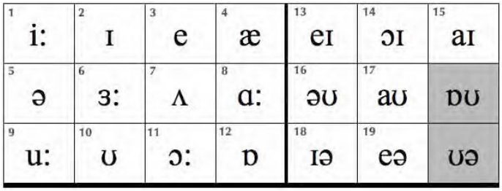

| **Vowels** | **Consonants** |
| --- | --- |
| 1-12 Monothongs  13-19 Diphthongs | 20 – 26 Plosives  27 – 34 Fricatives  35 – 36 Affricatives  37 – 39 Nasals  40 – 43 Approximants  44 – 45 Glottal |

**Exercise 1:**

**Listen and repeat each word: (A2)**

| **Short Sounds** | **Long Sounds** | **Diphthong Sounds** |
| --- | --- | --- |
|  |  |  |
| ɪ thin | i: need | eɪ pave |
| ʊ look | u: food | ɔɪ boy |
| e left | ɜ: turn | aɪ time |
| ʌ love | ɑ: heart | əʊ road |
| æ cat | ɔ: bored | aʊ down |
| ɒ lost |  | ɪə beard |
|  |  | eə chair |
|  |  |  |

**Exercise 2:**

**Decide if the words below are long (l), short (s) or diphthong (d) sounds. The first three have been done for you. (A3)**

| 1. laughL | 2. hotS | 3. sideD | 4. chip | 5. moment |
| --- | --- | --- | --- | --- |
| 6. worn | 7. machine | 8. lose | 9. round | 10. west |
| 11. cheers | 12. son | 13. book | 14. where | 15. are |
| 16. hat | 17. annoy | 18. bird | 19. meat | 20. have |

Unlike most modern languages, English is not phonetically written. This means that if you say words in the way they are written you will make pronunciation errors.

See the difference in meaning and pronunciation for the following words?

lose loose

An < s > in written English can be pronounced /s/ or /z/ in spoken English

**Exercise 3:**

**Say the words in the box, and put them into their correct column in the chart: (A4)**

| lease | plays lose | loose was lights | it’s peas | what’s crease |
| --- | --- | --- | --- | --- |
| is us | please | pass as stop he’s | who’s | chase |
|  |  |  |  |  |

| **s** | **z** |
| --- | --- |
| **lease** | **plays** |
|  |  |

**Exercise 4:**

**Listen to the audio (A5) and write the appropriate word associated with the category given on the left column of the table.**

| **Colour** |  |
| --- | --- |
| **City** |  |
| **Man’s name** |  |
| **Woman’s name** |  |
| **Make of car** |  |
| **Fruit** |  |
| **Vegetable** |  |
| **Animal** |  |
| **Famous English man** |  |
| **Famous English woman** |  |
| **Sport** |  |
| **country** |  |

The Schwa /ə/

The schwa is a very short, neutral vowel and most common sound in English. The exact quality of schwa sound depends on the consonants around it. It is found in virtually all English words with more than one syllable and it is the sound we use for the weak forms of many words.

E.g., earlier, cooker, painter, writer, teacher, soldier etc.,

The Schwa sound can replace any vowel sound in English.

E.g., a, an, the, some, and, but, of, from, for, at, them, us, that, as, than, there, am, are, was etc.,

Try pronouncing the following words with the Schwa sound.

A, to, the, mirror, memory, data, bigger, between, other, pencil, about

Spoken English is divided into strong and weak forms. The weak sound /ə/ is the most common sound in English /ə/ is found in unstressed syllables of words:

**Exercise 5:**

**Repeat the function word as a strong form, then as a weak form within a sentence: (A6)**

|  | **Function Word** | **Function Word In Sentence** |
| --- | --- | --- |
| **S. No** | **(Strong Form)** | **(Weak Form)** |
|  |  |  |
| 1  2  3  4  5  6  7  8  9  10 | For  Are  Have  As  To  At  Can  From  Her  do | Is that for John?  Are you ok?  What have you done?  As good as it gets.  Let’s go to the cinema.  She’s at school.  Can I help you?  It’s from Peter.  What’s her name?  Do you need some help? |

Intonation

Intonation is the movement in pitch of the voice. There are three intonation patterns in spoken English:

## 

Intonation tells us the speaker’s attitude to the words they are saying:

**Listen to the audio: (A7)**

**↘No (no) ↘↗No (maybe) ↗No (surprise)**

**Exercise 6:**

**Repeat the words in the box on the right:**

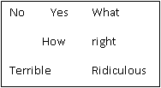

**A8.1**  ↘ Using Falling intonation

**A8.2**  ↘↗ Using Fall-rising intonation

**A8.3** ↗ Using Rising intonation

**Exercise 7:**

**Repeat after the recording. (A9)**

1. ↘No ↘↗No ↗No
2. ↘Yes ↘↗Yes ↗Yes
3. ↘What ↘↗What ↗What
4. ↘How ↘↗How ↗How
5. ↘ Right ↘↗ Right ↗Right
6. ↘ Terrible ↘↗Terrible ↗ Terrible
7. ↘ Ridiculous ↘↗ Ridiculous ↗ Ridiculous

**Exercise 8:**

**Listen to the words and write the pattern that you hear below: (A10)**

**1. 2. 3. 4. 5. 6. 7.**

**Exercise 9:**

* **Listen to the audio (A11) and write the sentences.**
* **You will hear the audio twice**

1. **_______________________________________________________________.**
2. **_______________________________________________________________.**
3. **_______________________________________________________________.**
4. **_______________________________________________________________.**
5. **_______________________________________________________________.**
6. **_______________________________________________________________.**
7. **_______________________________________________________________.**
8. **_______________________________________________________________.**
9. **_______________________________________________________________.**
10. **_______________________________________________________________.**

**Exercise 10:**

**Listen to the audio (A12) and complete the sentences. The recording will be played twice.**

1. What’s she ____________?
2. She is _______ TV?
3. I _________ TV at home.
4. How _________ are those _______?
5. What __________ do we ____________ on Friday?
6. We have ________ on _____________.